QUESTIONNAIRE 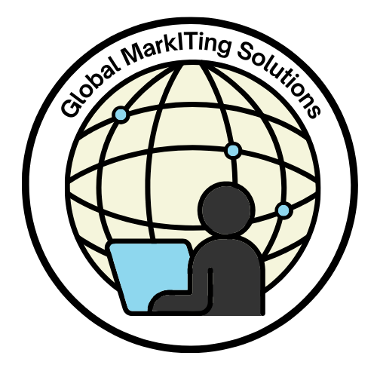
Please complete and email Bev mossreilly@gmail.com

What would you like to achieve from an online presence? Did I hear you say that you have one?
What do you have? Would you like to share it with me by ticking (crossing) the boxes?
Let me analyse your answers and send you a comprehensive response.
An attractive fully optimized website
Blogs/ Articles that are posted to your website a minimum of 3 times a week
The full social media spectrum inclusive of:
LinkedIn
Facebook
Instagram
X (Formerly Twitter)
Tik Tok
YouTube
Pinterest
Google Business Listing
Are you posting once a day at the right time? Do you know the best time to post?
Are you boosting posts and choosing audiences?
Are you following Google’s algorithms and keeping up to date with regular changes and updates?
Are you aware that Meta changes algorithms all the time and that if you don’t keep abreast of them, you’re sinking to the lowest ranking?
Even LinkedIn upgrades. Do you stay on top of them?
Are you being looked after by a service-oriented client-centric team who are specialists in the field and want to see you succeed by creating a robust online presence?
Are you paying an arm and a leg and not seeing your audience grow?
BY NOW YOU’RE OVERWHELMED, RIGHT?

People try to do this themselves to save money. The questions we ask are:
Do you have the time to create your own SEO website, blogs, and set up all the necessary social media platforms and accounts as listed above?
Do you have the knowledge to do the above with precision and passion?
Do you follow Google’s algorithms and know exactly what is required to build an audience of followers?
Do you have the time to dedicate yourself to your job and still devote hours to creating and elevating your digital footprint.
Do you understand SEO – Search Engine Optimisation, and SMO Social Media Optimisation?
Do you know how to link social media platforms to your website?
What do you wish to achieve?
What are your expectations of us?

If you haven’t ticked every box, let’s get real and cut to the chase – you don’t have a well-informed dedicated team of experts who are truly looking after you and doing the job that you require to see results.
Let’s cut through the hype even further.
Here’s the thing: we aren’t here to replace you… we’re here to expose your business, your goals and ambitions, and that which you wish to achieve.
Without our service, you’re not falling behind... you’re being left behind.
If these statements resonate with you, you need our services and we’re here for you.

Do I hear you say that you’re a start-up or that you are going through lean times and you need to cut marketing or delay it? WRONG – that’s when you need it most.
Marketing your business is a necessary investment. With Global MarkITing Solutions you will see a return on your investment. Your business is your asset, and we all want to see assets grow and not plummet. Isn’t it a no-brainer, really?
Your results today equal your identity today. If you want growth and exposure, you’ve got to shift from where you are.
You’re busy doing what you do best. We’re not making a fool of you. You’re the expert in what you do, and that applies to us too at Global MarkITing Solutions https://www.globalmarkITingsolutions.co.za
We are three specialists in our fields who focus on our greatest strengths and what we do best. All of us have the knowledge and skills to offer you a service whereby you will see your business grow and achieve your goals.
Whether you’re a dentist, a doctor, a psychologist, a social worker, a physiotherapist, or any other professional, …. or even in the hospitality trade – we wouldn’t attempt to do your job. And why not? Because you’re the specialist in YOUR field.
Contact us today wherever you are in the world.
Bev +27 651384801 mossreilly@gmail.com

WE WILL PROVIDE THE FULL TURNKEY SOLUTION AS EVERY ASPECT PLAYS AN ESSENTIAL ROLE
Step 1: Create a website
Step 2: What is the message you wish to convey, and what do you hope to achieve?
Based on the intentions of your content, we create your SEO website, the Content
Pillars, inclusive of blogs and your social media.
Step 3: Correct boosting, linking and traffic flow created by specialists in the field achieve the results.
- 2. 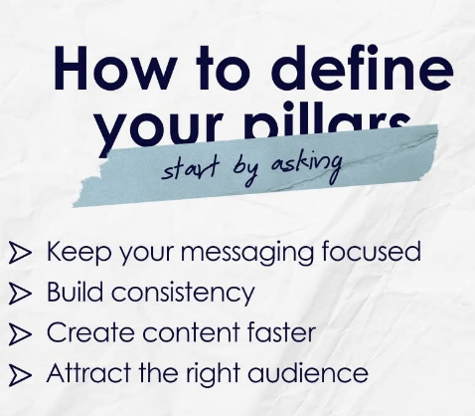
3.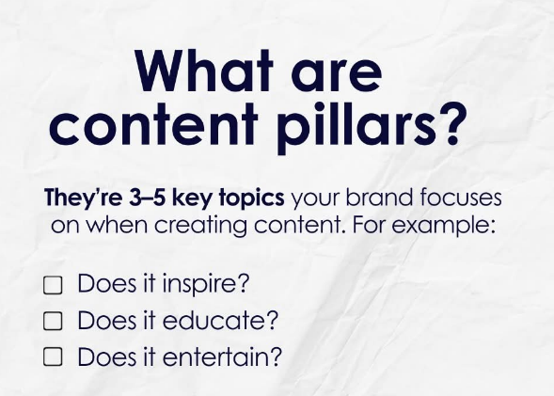 4. 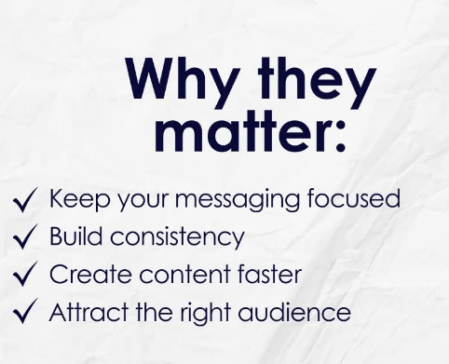

SEO + SMO = THE OUTCOME YOU DESIRE
Omitting blogs or /and social media means you will remain in the dark!

Take the first step and respond.

